**Java Basico**

1.1

Interfaces: <https://campus.open-bootcamp.com/cursos/5/leccion/64>

2.1

Instalar Java y similares: <https://campus.open-bootcamp.com/cursos/5/leccion/2490>

<https://campus.open-bootcamp.com/cursos/5/leccion/2491>

Java desde IntelliJ: <https://campus.open-bootcamp.com/cursos/5/leccion/2493>

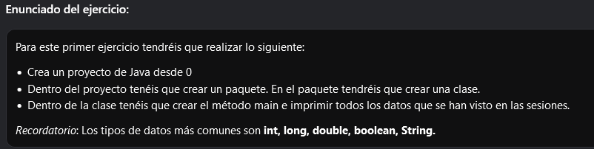

3.1

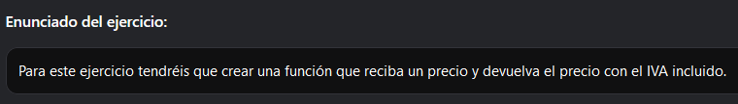

4.1

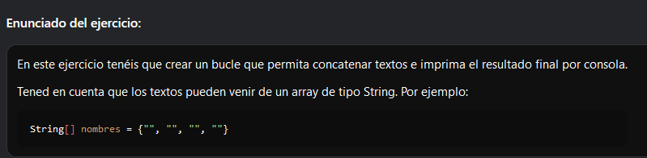

5.1